2. Show how the following values would be stored by byte-addressablem achines with 32-bit words, using little endian and then big endian format. Assume each value starts at address 0x10. Draw a diagram of memory for each, placing the appropriate values in the correct (and labeled) memory locations.
- 0x456789A1

- b) 0x0000058A

- c) 0x14148888
6. The first two bytes of a 2Mx16 main memory have the following hex values:
Byte 0 is FE
Byte 1 is 01
If these bytes hold a 16-bit two's complement integer, what is its actual decimal value if:
- memory is big endian?

- memory is little endian?

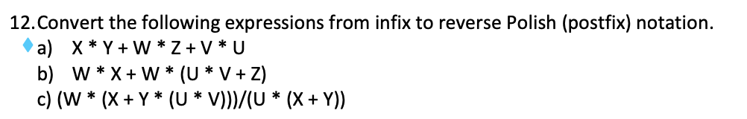
ANSWERS:
A)
B)
C)
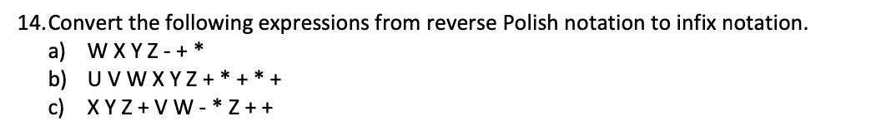
ANSWERS:
A)
B)
C)

20. What is the difference between using direct and indirect addressing? Give an example.

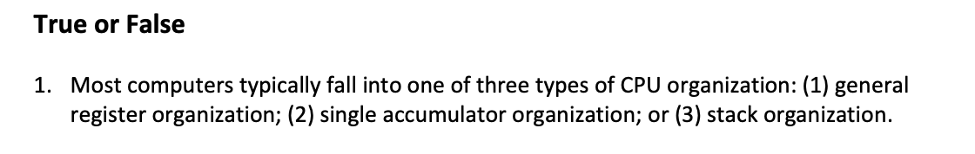
8. Expanding opcodes make instruction decoding much easier than when it is not used.

10. The effective address of an operand is the value of its actual address in memory.

